Many The Miles:
Paving the Way to Post-Graduation Student Success

Heidi Bird
Pepperdine University
June 18, 2013
Dr. Margaret Riel, Thesis Adviser

INTRODUCTION TO THE PROBLEM

In our pursuit of career success, we are like cars on a highway, speeding along in the same direction. Because we are so focused on our destination (the perfect career), we often believe that there is only one route to career advancement. This tunnel vision can keep us from seeking alternate routes, either on our own or by asking directions of others, who may guide us in a direction we would not otherwise have gone. Being open to other possibilities might allow us to progress more quickly—or lead us to a new and better destination.

This action research project is a self-study of a newly hired Student Success Center Manager (Carrington College California Pomona) with a broad background in education. I intend for this project to be an example of first-person action research in the search of practice improvement.

After spending a few months in my new role on campus, I feel that the faculty and staff on our campus are succeeding in meeting our position-specific goals in helping our students graduate. Our faculty is comprised of effective instructors in their specific classes. Our staff members meet our goals and communicate with each other effectively. Our goals are always centered on helping support our students.

The overall goals of my action research as I begin this project are:

1. To investigate how I can best assist students in meeting or exceeding long-term career goals at Carrington College California Pomona.
2. To broaden my initial job description so that it includes collaboration with the Career Services department.
3. To collaborate with faculty and staff so that we see a bigger picture of how we can work together to help our students succeed.

This project unveils a process of action and reflection in which I search for ways to improve my practice as Student Success Center Manager and ultimately set myself apart as a “quiet innovator” at work.

Evidence for reflection is drawn from survey feedback and from conversations with students and faculty on the CCCP campus.

Community of Practice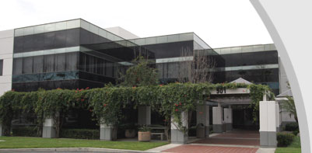
I began working as the Student Success Center Manager at Carrington College California Pomona (CCCP) in February 2013. Formerly known as Western Career College, the Carrington College California system of nine campuses boasts extensive career assistance to students, helping them pursue professional success through education. Our instructors provide hands-on training that prepares students to enter the fields of medical assisting, dental assisting, pharmacy technology, veterinary technology, and medical billing and coding. Personal and professional development, communication skills, respect and responsibility are emphasized throughout the duration of our programs. Programs culminate in a Certificate of Achievement or Associate of Science degree awarded upon successful completion of all required coursework and externship.

My position as Student Success Center Manager is new to our campus. In fact, CCC Pomona was the final campus to add this position to the staff. Because our campus is so small, the budget did not allow the addition to the staff until enrollment reached two hundred students. My position was added when enrollment hit that mark.

The CCC Student Success Centers were developed as a result of student feedback (survey data) gathered in the last two years. When I was hired, my Executive Director and I explored the campus and chose a suite of offices to transform into Pomona’s Student Success Center. Two staff members actually had to move into another section of the office in order to transform the space.

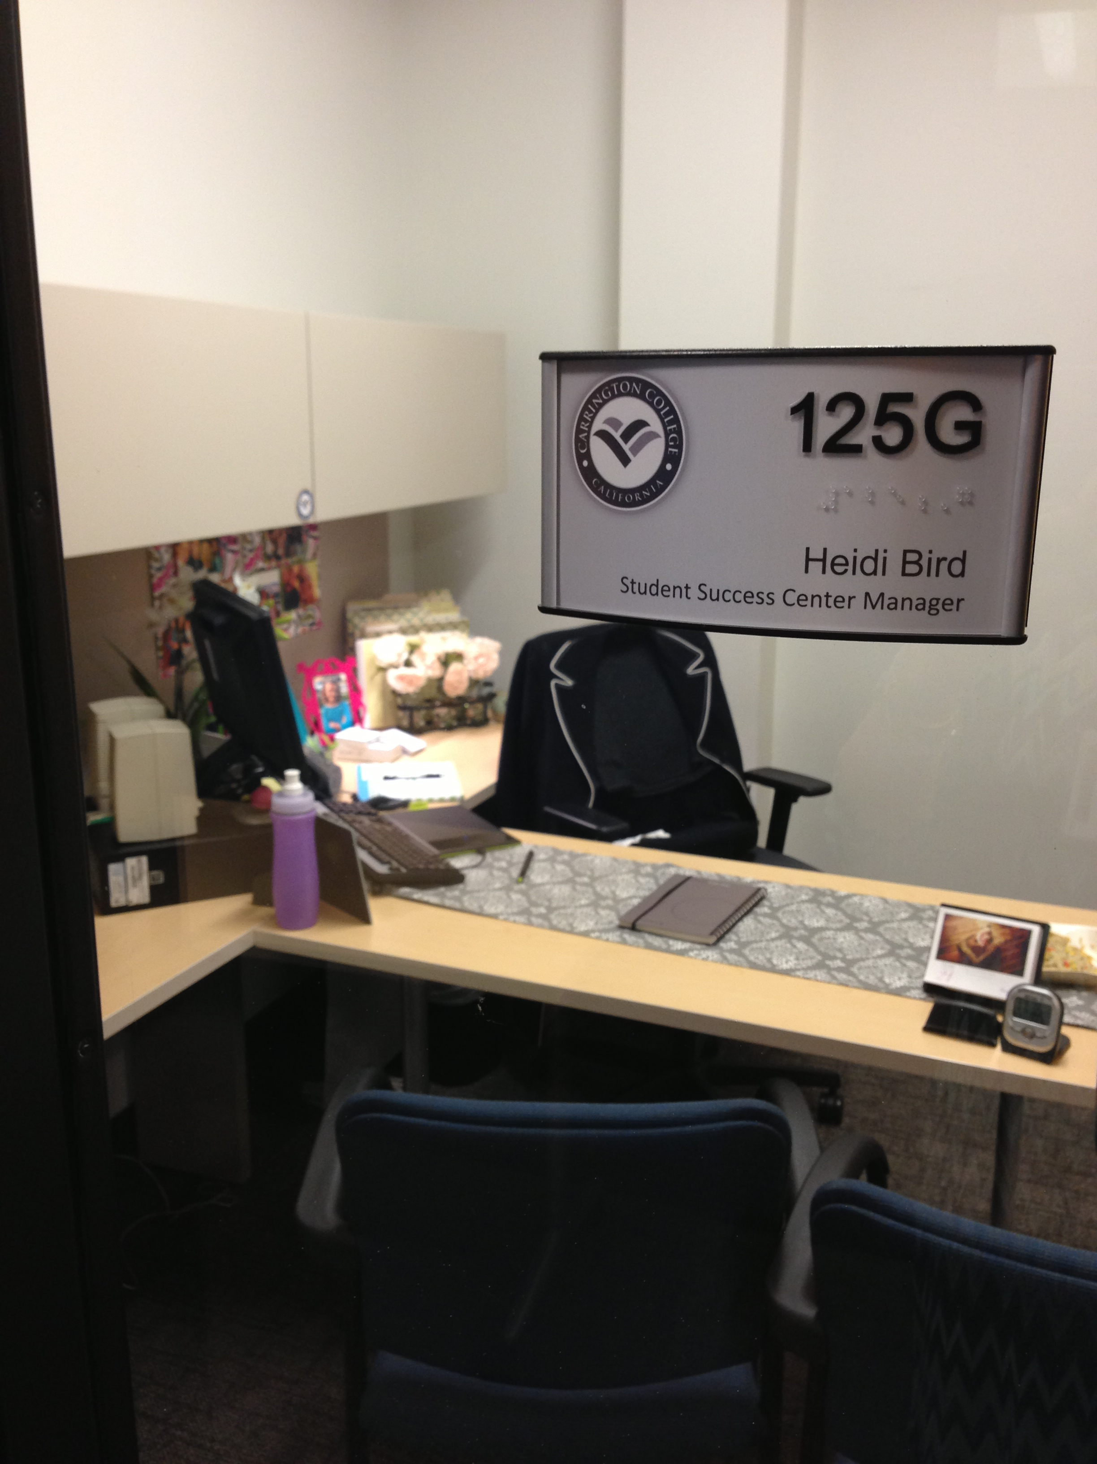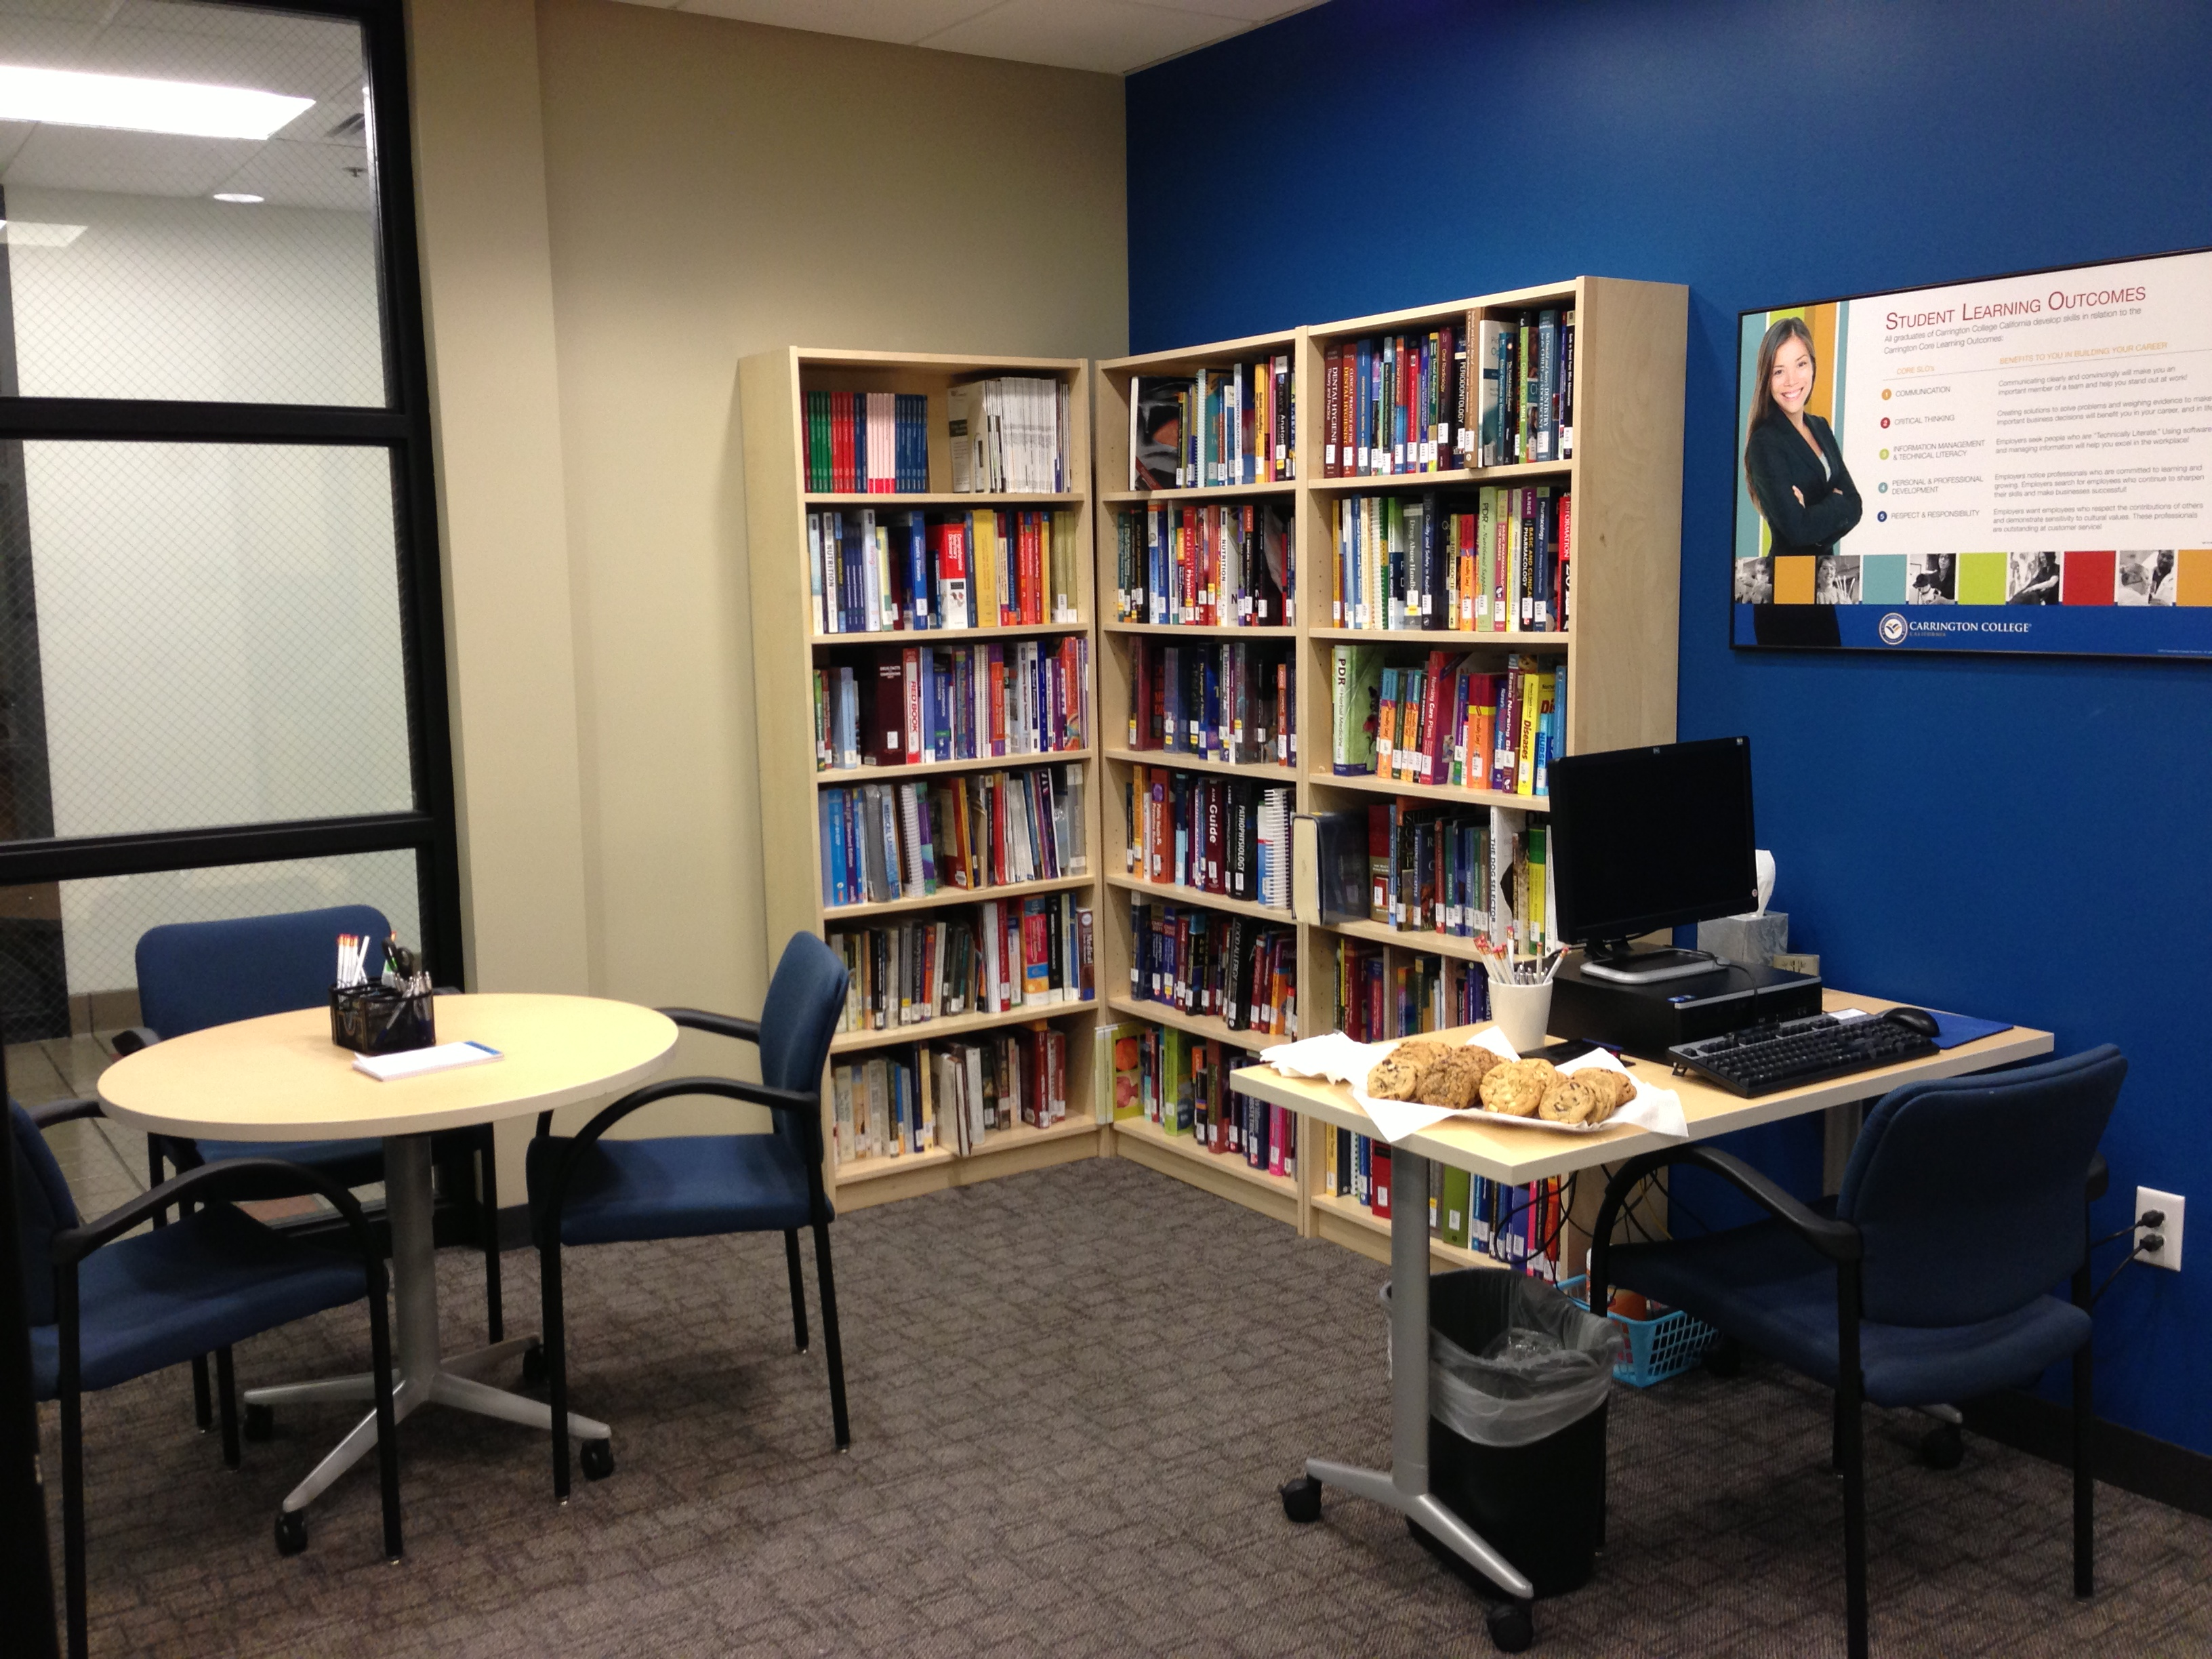

Pictures of my office and the rest of the Student Success Center

Our Student Success Center (SSC) offers program textbooks, reference books, journals, two computers, a study room, and a conference room for larger study groups. My office overlooks the SSC so that I am available to assist the students at any time while completing other work required for my position. Approximately half of my workday is spent assisting students with their online classes. I track their grades and reach out to students when their grades are slipping. I also report online grades to Program Directors, who assign mandatory tutoring for students who are falling behind. I mostly work with the Vet Tech Program Director, Vanessa, because 75% of our students are enrolled in the “VT” program.

I also spend a fair amount of time working as an assistant to my Executive Director, Colleen. Of note, I have assisted her with conducting student surveys and presenting New Student Orientations.

I participate in weekly phone meetings with the SSC Managers at the other eight campuses. We discuss best practices for student success, as well as any issues that come up during the week. I have also been asked to listen in on the weekly Academic Dean phone meetings so that I can get acquainted with their job requirements. Within the first six weeks of starting in my position, I was approached by my Executive Director (who hired me) to be thinking about whether or not I would consider applying for the Academic Dean position at CCCP. Because our campus is so small, the budget had not allowed for an Academic Dean position. The Executive Dean, Colleen, has been acting as the Dean for the last year, until the budget will allow for the addition of a Dean. She expects that the position will be added in the next year if our rate of student growth remains steady, and we are discussing the possibility that I might take on the role.

Exploring the Current Landscape of Developmental, Reflective and Representational Student E-Portfolios: A Review of the Literature

Heidi Bird
Pepperdine University
Master of Arts in Learning Technology

Exploring the Current Landscape of Developmental, Reflective and Representational Student E-Portfolios: A Review of the Literature

Introduction

The use of portfolios as a tool to assess student success and capability has a long history in education. Portfolios have been used in a myriad of situations in the academic setting. Students use them as a showcase of their work for teacher and parent review, college preparation, and career preparation. While print portfolios are private and only available for one reader at a time, current literature suggests that transitioning from traditional portfolios to e-portfolios allows creators to showcase their skills to a much broader audience by making use of dynamic web-based software. Using software online allows complete creative control of functionality and design. E-portfolios also boast vast amounts of storage, access, management, interactivity, and real-time functionality. Knight, Hakel, and Gromko (2008) conducted a study examining the relationship between e-portfolio participation and student success. Despite some limitations, their current study has demonstrated that undergraduate students who created e-portfolios had significantly higher grade point averages, credit hours earned, and retention rates than a matched set of students who had not.

The landscape in which e-portfolios are being developed and showcased in education is constantly evolving with the current use of Web 2.0 tools. Currently, these e-portfolios can take many forms: websites, blogs, Tumblr pages, YouTube videos, or vlogs (video blogs). Student e-portfolios are created by collecting artifacts from academic experiences and then presenting them digitally. A profusion of tools can showcase these artifacts in impressive ways that may set students apart from test scores or grade point averages.

This literature review will support Villano’s (2006) claim that the current use of e-portfolios in education falls into three broad categories: developmental, reflective, and representational. This literature review defines and examines the most effective use of each of these categories of e-portfolios on the current literature. This review aims to establish an understanding of what characteristics can create effective e-portfolios and mindfully apply these characteristics that can assist others in creating their own e-portfolios for educational or career use.
Developmental Student E-Portfolios
Developmental e-portfolios serve as a selective and purposeful collection of a person’s creative output of work and ideas and as a tool to help the student be unique and distinctive. Creating portfolios allows authors the ability to plan, assess, and reflect upon their learning and their body of work during a specific period of time. A developmental portfolio stores information and represents their growth, accomplishments, and reflections. These digital collections of work are a rapidly emerging, powerful, interactive mode for capturing student work and enabling faculty to assess student learning (Whitworth, J., Deering, T., Hardy, S., & Jones, S., 2011). E-portfolios provide multidimensional assessment data to present the student’s learning process while allowing students to explore the digital world. As students become more comfortable in the digital world, they are easily able to collect, store, and share information. In turn, educators have responded by increasingly using technology in teaching (Rhodes, 2011).

Increasingly, educational institutions are encouraging, or even requiring, students to create their own personal e-portfolios as a repository for demonstrating accomplishments and activities (Young, 2002). In a time when standardized testing has become an integral focus in K-12 education, there is a need for demonstration of a much broader array of learning outcomes. These include personal and social responsibility, teamwork, intercultural knowledge and competence, and integrative learning (Rhodes, 2011). E-portfolios meet this need by enabling students to improve and focus their learning and provide them with a tool to showcase their skills in personal ways, getting away from being defined simply by their test scores. Cambridge (2008) reported that e-portfolios are more flexible than standardized testing and more easily comparable across a program or institution than the results of authentic assessments at the course level, such as papers, projects, and exams. A portfolio of assignments over a specified period of time allows a student to be evaluated more appropriately and objectively by allowing students to integrate a large sampling of work in a course. This sampling allows students to connect new ideas with the student’s existing knowledge and context. In fact, Mason, Pegler & Weller (2004) argued that student ownership of their e-portfolio and their choice of artifacts to include make the creative process a truly learning-centered activity.
At the college level, e-portfolios are increasingly being used to track progress toward general education outcomes. Advocates of this approach see e-portfolios as easily comparable across a program or institution than the results of authentic assessments at the course level, such as papers, projects, and exams (Cambridge, 2008). Tubaishat and Akram (2009) explained that in recent years, colleges and universities have been seeking alternative avenues to provide an attractive curriculum that integrates technology in order to meet requirements of regional and professional accrediting organizations. Many higher education institutions have adopted an outcome-based educational model to move away from the GPA driven model. They also explain that outcome-based education is a method of education that focuses on what students can actually do after they are taught a particular subject. All curriculum and teaching decisions are made based on how to best facilitate the achievement of a desired outcome.

Tubaishat & Akram (2009) also argued that e-portfolios are an effective tool for faculty to better manage, review, reflect, and comment on student work. Because of these advantages, teachers and institutions spend valuable time and financial resources on e-portfolio implementation and development. However, research suggests that most student e-portfolios represent only a limited period of time. For instance, Shepherd & Hannafin (2008) surveyed seventeen student teachers who had created e-portfolios as a requirement for graduation, finding that the development of e-portfolios benefitted their teacher preparation. Creating e-portfolios encouraged them to consider alternative viewpoints, reflect deeply on teaching experiences and form goals. However, the participating students did not anticipate using them in future employment situations because of time constraints, lack of incentives, and conflicting institutional interests.
Reflective E-Portfolios in Education
While developmental e-portfolios have long received attention as an effective type of student assessment and as a way to capture a snapshot of a student’s learning process, there is growing concern that reflection about the learning process is being lost in favor of meeting requirements to earn grades. To address this concern, some researchers are turning their attention to reflective e-portfolios. Rather than an assessment of learning, reflective e-portfolios provide assessment for learning. They provide students with the opportunity to reflect and thus enable them to better understand their own learning, painting a richer picture of their work to document growth over time. Cambridge (2003) explained that reflection over time increases a student’s ability to make sense of a concrete experience.

Reflective e-portfolios can be challenged as a means of effective student learning, because reflection is a skill that is vaguely defined. Jenson (2011) studied the role of reflection in learning processes in a case study at the University of Minnesota Deluth. Her case study focused on the potential of prompting her first-year writing students over a period of eight fall semesters to write more critical reflection statements while developing their own reflective e-portfolios. During any given class period, Jenson posed “how” and “why” questions that encourage a deeper understanding of the given assignment. Her students received a rubric with these questions so that they could focus on her questions/prompts when writing their reflections outside of class. After studying the student reflections, Jenson reported that being intentional about classroom pedagogy helped elicit deeper reflection. Her goal in providing reflective questions helped students reach the point when they could begin to critically reflect on learning independently.
Jenson’s results also indicated that the use of student surveys and focused in-class discussions in conjunction with consistent e-portfolio assignments dramatically increased the length of student reflection statements written and fostered the depth of thinking shown in those statements. Her results demonstrated the effectiveness of using intentional instructional strategies for helping students develop self-regulation and critical reflection skills.

Representational E-Portfolios in Education

Often considered “portfolios for marketing” (Barrett, 2005), representational e-portfolios are most commonly created to enrich student marketability, providing potential college admissions recruiters or potential employers assurance that the student has a firm grasp of current technology uses. These selective e-portfolios allow students to present a comprehensive overview of academic and extracurricular activities along with self-reflection and supporting evidence (artifacts) to a potential employer in creative and dynamic ways. Mason, Pegler, and Weller (2004) described representational e-portfolios as self-selected multimedia presentations of student work that offer a rich and textured view of student learning and development over the course of their education. Creating these e-portfolios can tie together career, community, personal, and educational goals. They argued that effective representational e-portfolios are created when students continually contribute to their e-portfolios throughout their “learning life” show academic growth and record of achievement.

Because these e-portfolios are typically voluntarily created, students can let their personalities show through using photography, video, music, or artwork. However, McAlpine (2005) cautioned that students might end up including sub-optimal work – such as the first draft of an essay or the reflection that the individual had missed the point of a science lesson. Students must be selective in their choices and confident in their power to control the narrative of their e-portfolio, or should seek guidance from an educator to screen their work.

Soon-to-be new college graduates are encouraged, especially, to develop representational e-portfolios as documentation of their professional skills and accomplishments in order to find employment. Whitworth et al. (2011) studied the perceptions of school administrators and teacher educators regarding the effective use of portfolios in the process of hiring new teachers in 2011. Advantages and disadvantages regarding portfolios as an effective tool in the hiring process were identified along with several barriers to their more extensive use. Specifically, findings of this study indicated that school administrators and teacher educators agree that there is value in using portfolios in the teacher hiring process. However, while both groups acknowledged the usefulness of portfolios, both saw them as only one of several tools to be used in teacher employment decisions.

E-portfolios can provide applicants the opportunity to distinguish themselves from the applicant field by the type and quality of their e-portfolio items, a great advantage. Applicants can also use the e-portfolio to highlight their strengths as a teacher. However, in sharp contrast to this strength of e-portfolio use, the accuracy of demonstrating the applicants' actual teaching skills and ability is a great disadvantage. Because applicants can self-select items for the portfolio and can structure and present it in a way that puts them in the best possible light, administrators in hiring roles doubt the confidence that can be placed in the e-portfolio.

Finally, Whitworth et al. (2011) identified time as a major barrier to the effective use of e-portfolios in the hiring process. Because school administrators typically have demanding schedules and responsibilities, the process of interviewing and hiring teachers can be limited by serious time constraints. This makes it very difficult for them to give more than a cursory review of applicants' e-portfolios. Thus, the time spent creating dynamic and thoughtful e-portfolios may be wasted.

Conclusion
E-portfolios prepare students for career advancement in education and beyond. I have reviewed the use of e-portfolio in three areas: developmental, reflective, and representational. The studies exploring developmental indicate that students benefit from selecting powerful examples of their work and ideas to showcase skills. Reflective e-portfolios provide students with the opportunity to reflect and thus enable them to better understand their own learning, painting a richer picture of their work to document growth over time (Cambridge, 2003). And from the research on representative portfolios students can focus on what unique qualities set them apart from other job candidates.

CYCLE ONE REPORT

RESEARCH QUESTION:

How can I effectively introduce a presentation that engages students and inspires them to develop dynamic representational career e-portfolios?

PREDICTED OUTCOME:

The use of the web presentation tool Prezi will allow me to explain clearly the steps required to create a simple career e-portfolio. The use of a web-based survey will allow me to collect data about how effectively I presented the information. The survey will also allow me to evaluate the usefulness of my presentation for the students to whom it is presented.

ACTION TAKEN:
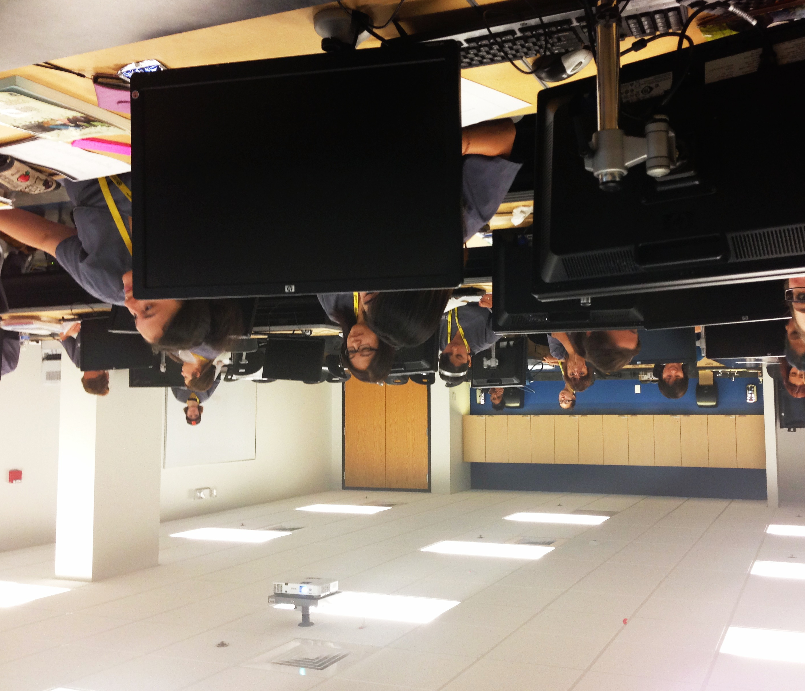
1.1 Dental Students in the Student Lab

This cycle began with a verbal conversation on March 1, 2013 with Jennifer, the Dental Instructor/Program Director. We discussed the possibility of me presenting a workshop to her dental assistant students on creating a website (e-portfolio) in thirty minutes. Jennifer was very receptive to the idea, and even said that she was excited to learn this skill for herself. We made plans for me to present the workshop to her students on March 19th, 2013.

I presented my workshop, “Your Website in 30 Minutes or Less,” on March 19, 2013 in the computer lab upstairs from their classroom. The students entered the classroom and each logged onto a computer. I started the workshop by explaining that the presentation was for my Master’s Degree, and that I would be asking for feedback at the end.

My first step was to show them examples of websites I have created using Weebly (www.weebly.com) and the reasons why I created them. I asked the students to sign up for Weebly and follow along with me as we took the first steps in creating their own website:

- The first step on the path of the Prezi was an overview of the presentation.
- The title of the Prezi is “Your website in 30 minutes or less.”
- I briefly introduced why they might want to create a website. I mentioned that e-portfolios are a great way to present yourself if you are looking for a job. A career e-portfolio is a powerful way to set yourself apart from other job applicants. I also asked them how else they could utilize a website. Answers included family websites and business websites.
- Each student navigated their way to Weebly. I then asked them each to enter their name and email address, and create a password.
- I showed them an example of my registration information.
- I asked them to choose the “portfolio” category.
- For “website title,” I asked them to enter their name. I explained that after registering, it is simple to go back and edit their website details.
- For “website subdomain,” I asked them to use their name again.

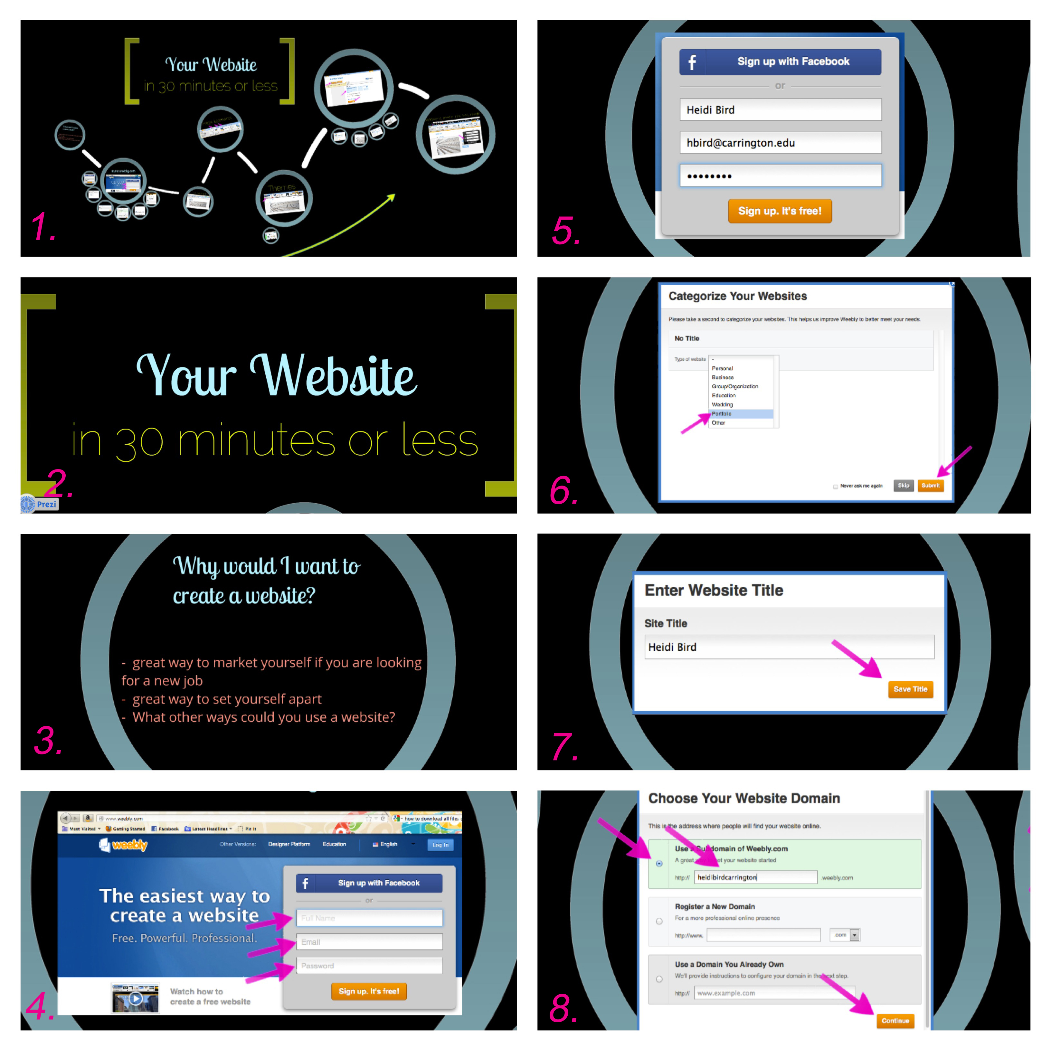
1.2 Prezi slides 1-8

- As they pondered their website address ideas, (perhaps they wanted to choose a different address than their name) I suggested that they keep the address simple, short, and to avoid numbers or symbols.
- Students were asked to check that their website address was how they wanted it to appear, to check the box that shows their website title at the top of the page, and to save their work.
- I introduced the students to the dashboard, the main hub of Weebly.
- The dashboard gives you the ability to quickly view the important tools for creating your website, the three most important components being “elements,” “design,” and “pages.”
- Ten minutes were spent on the “themes” section of the “design” page.
- We spent time looking through the different categories of themes (business, education, general purpose, personal, simple, etc.).
- On the “pages” tab, we perused the different layouts we can use for a page.
- I suggested that they create a two-page website to begin. Along with their home/splash page, they can create an “about me page” with a simple headshot and a paragraph about themselves (innocuous facts like a favorite hobby, their favorite pet, why they got into their chosen career).
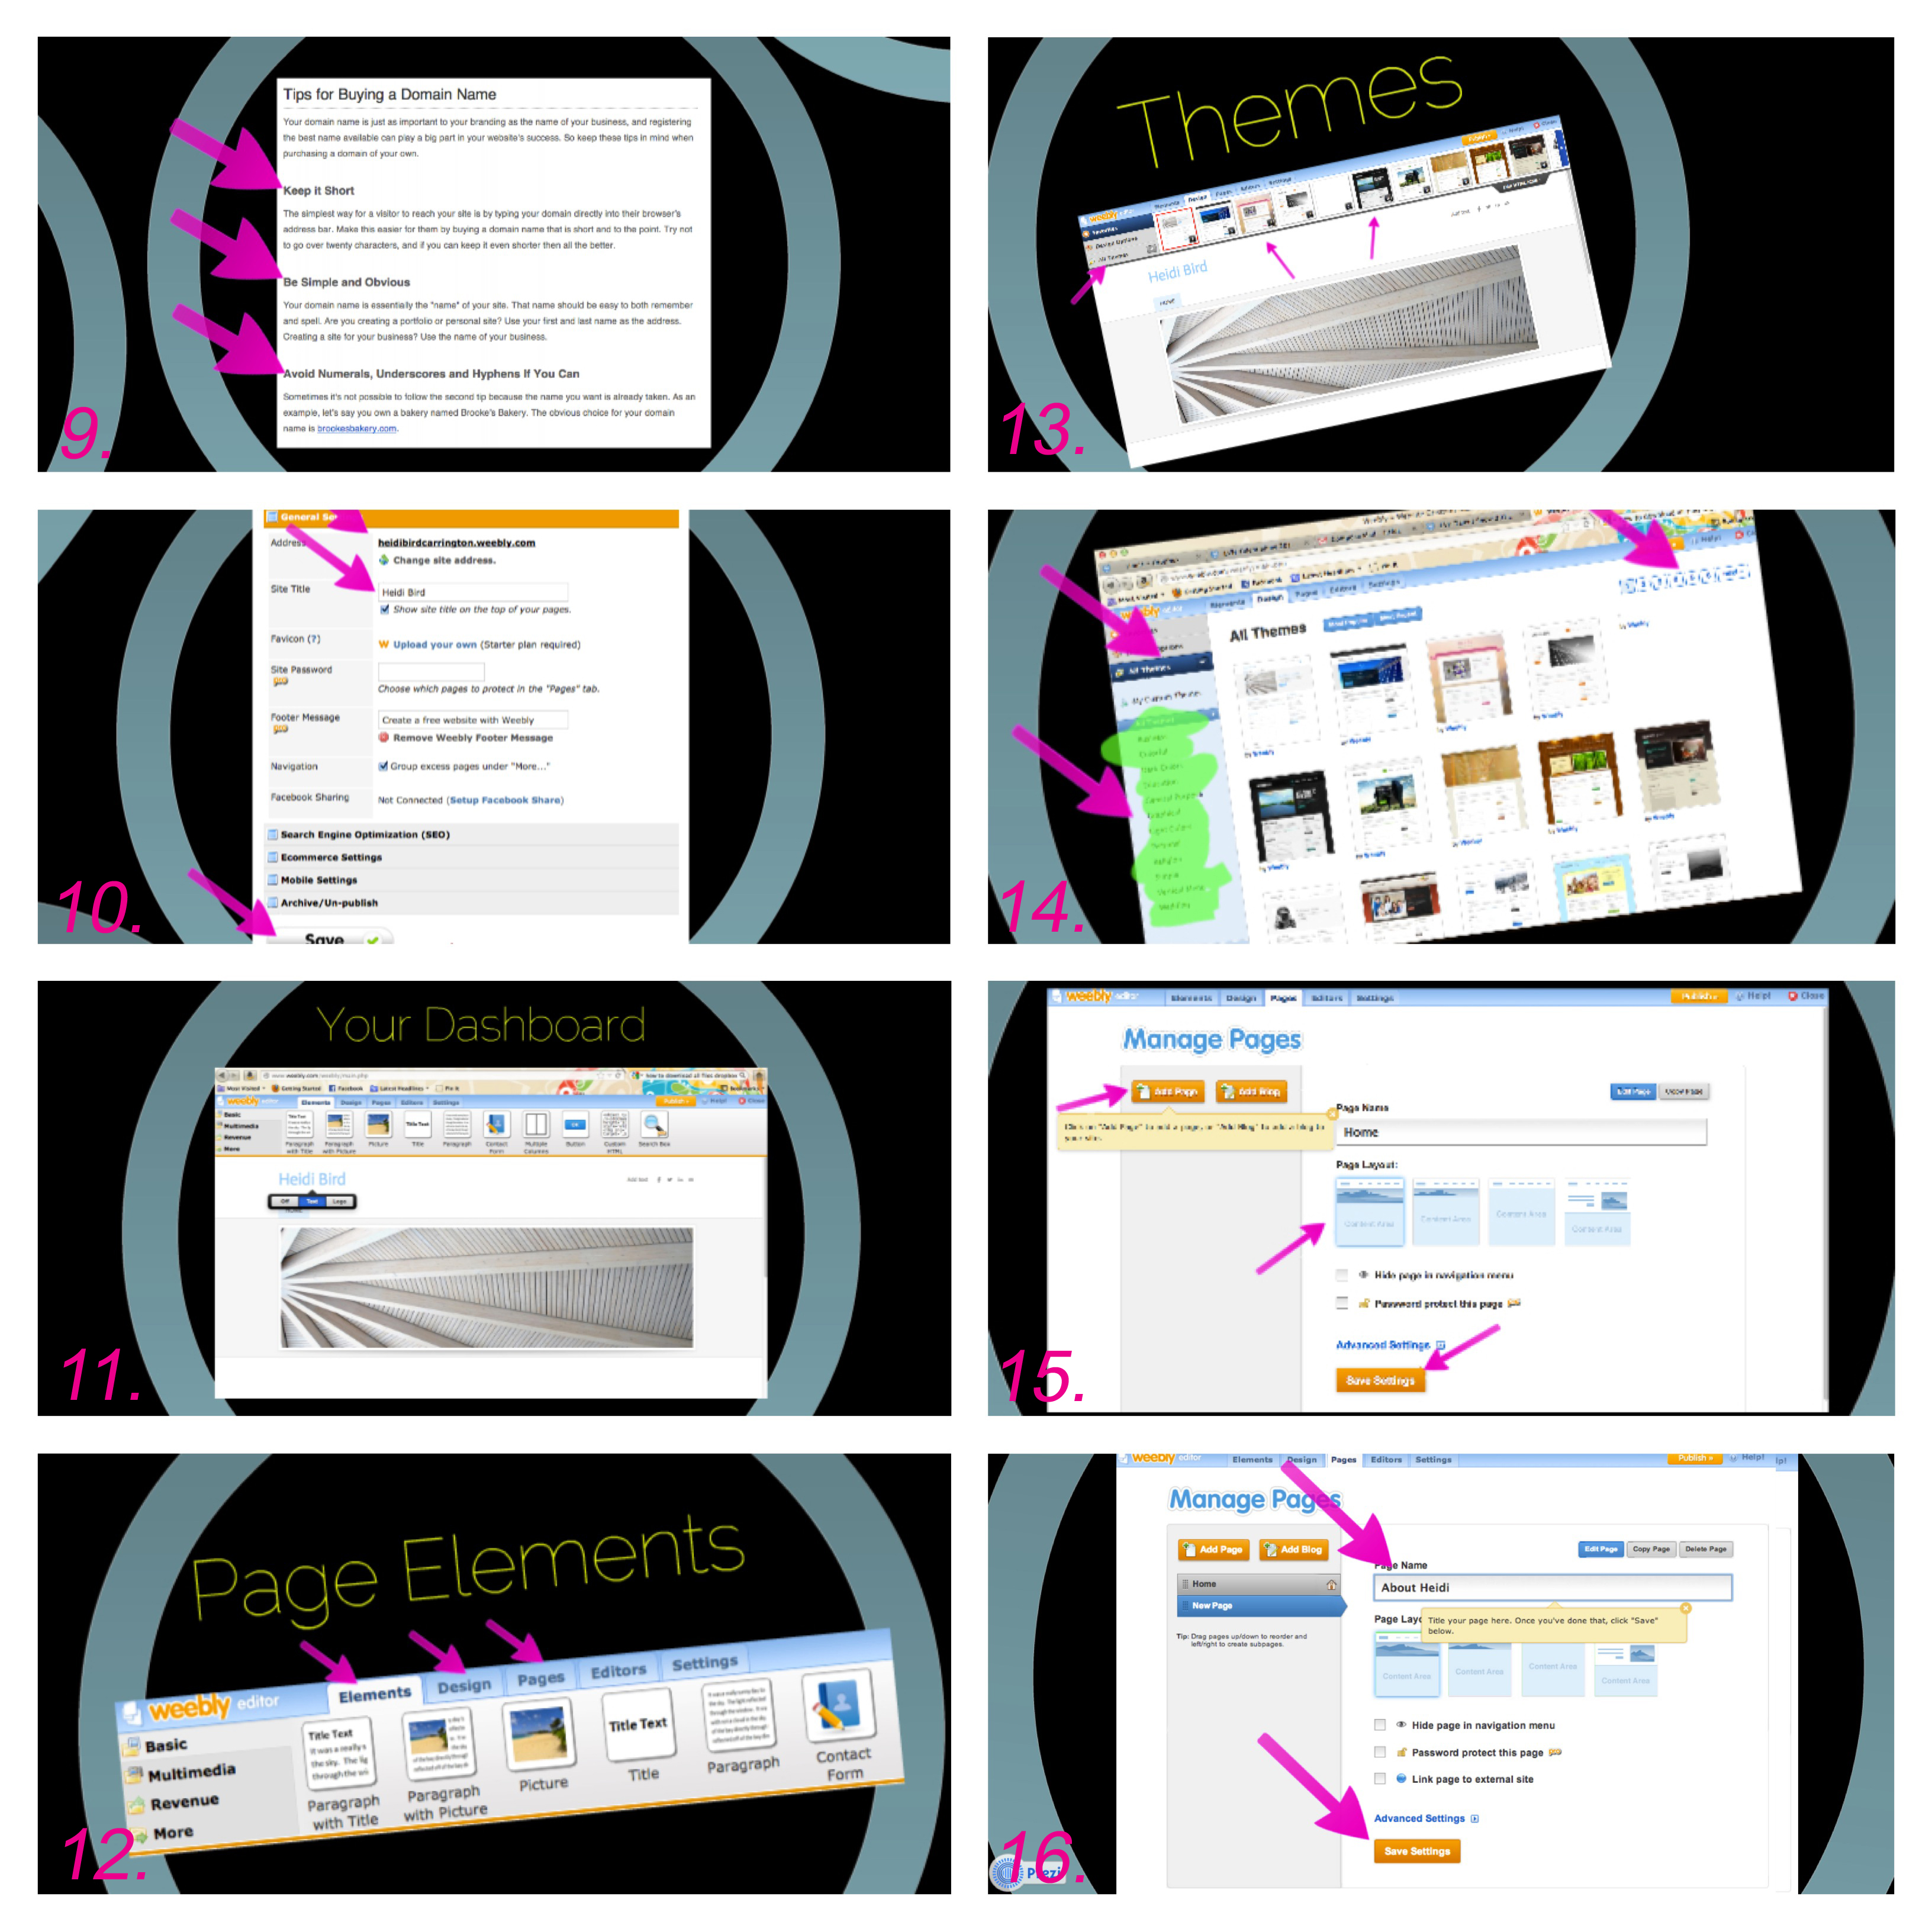
1.3 Prezi slides 9-13

- I showed an example of what their new “about me” page would look like.
- I stressed that webpage order is flexible when using Weebly.
- To explain how to edit the “about me” page I demonstrated dragging elements down to the page (picture, text box, etc.).
- Finally, I demonstrated how to add links to their existing social media networks like Facebook, Twitter, LinkedIn, and email.

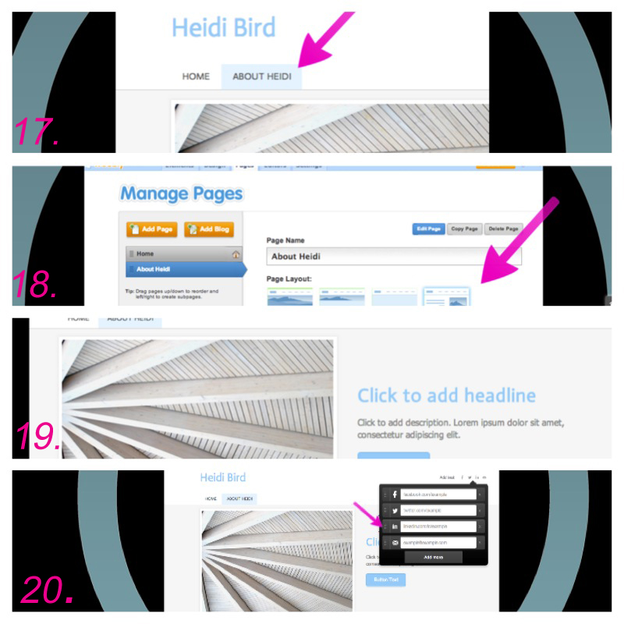

1.4 Prezi slides 17-20

EVIDENCE USED TO EVALUATE THE ACTION:

After completing the workshop, I asked the students to complete a short survey I had created for them. I wanted to discover what information made the biggest impression on the students, whether they found the content to be relevant to their career goals, and what digital tools they would be interested in learning about in the future.

The students entered a web address for the SurveyMonkey survey I had created to assess the workshop. The link for the survey provided by SurveyMonkey was long, so I shortened it using the website bit.ly.
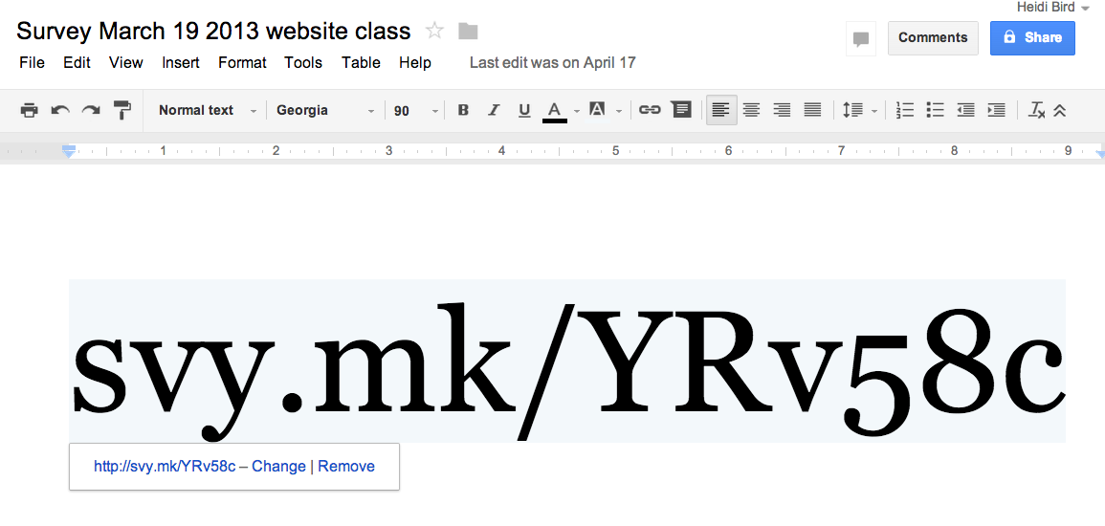
1.5 SurveyMonkey shortened website address using bit.ly

EVALUATION/REFLECTION:
My first cycle was planned in the first month beginning in my new position at Carrington. My literature review had investigated different types of e-portfolios in education, and I wanted to see how I could use that knowledge in my new workplace. I was hopeful that a workshop on e-portfolio creation would prove to be helpful to the dental students. I specifically wanted to focus on the creation of representational e-portfolios, which focus on highlighting the unique qualities that set the students apart from other job candidates competing with them.
I planned this cycle under the assumption that the students at CCCP had been working with Sandee (Manager, Career Services) consistently to create their résumés and cover letters so that they will be prepared to be placed in their externships during their final term. Because I assumed that the students had already been taking the first steps in career advancement preparation, I wanted to go a step further and show the students what else they could do to set themselves apart from other job applicants.

CYCLE TWO REPORT

RESEARCH QUESTION:

How can the
- review of the data from Cycle One
- interviews with faculty, instructors, and students
- investigation of the characteristics of effective CTE (career and technical education) programs

refocus my approach in developing another workshop to the dental students, targeted to real current needs of students in order for them to obtain employment post-graduation?

PREDICTED OUTCOME:

The data collected in Cycle Two will refocus my efforts in presenting a new workshop, which will better meet student needs in obtaining employment.

ACTION TAKEN:

This cycle consisted of data evaluation of the survey results from Cycle One, as well as conversations with colleagues and students on campus from March 19-April 24, 2013.

EVIDENCE USED TO EVALUATE THE ACTION:

Survey Data Analysis

The day after completing the Prezi workshop on March 19th, I analyzed the student survey data collected from the SurveyMonkey survey. I copied the data from SurveyMonkey to a Microsoft Excel spreadsheet so that I could better view and analyze the collected data.

Most of the data collected from the multiple-choice questions was overwhelmingly positive. The data indicated that:

- 92% of the students found that the workshop content was “very” or “extremely” organized.
- 100% of the students felt that the workshop was “very or “extremely” useful.
- 82% of the students found it to be “very easy” to keep up with the rest of the class using weebly.com during the workshop.

One multiple-choice question indicated the least conclusive results. 58% percent of the students reported that they would like to learn more about other digital tools to advance their career. 33% answered “maybe,” while 8% answered that they are not interested.

“If you could request another workshop, what would it be?”
One in fifteen students requested more information on creating e-portfolios using weebly.com, one in fifteen students requested to learn about creating presentations with Prezi, one in fifteen students requested to learn about creating PowerPoint presentations for class assignments, and two in fifteen students requested to learn how to write a résumé. Ten out of fifteen students chose not to answer this question.

2.1 Survey Question #1: “If you could request another workshop, what would it be?”

“How useful did you find this workshop?”
Two out of fifteen students found the workshop to be “extremely useful.” Ten out of fifteen students found the workshop to be “very useful.” Three out of fifteen students chose not to answer this question.

2.2 Survey Question #2: “How useful did you find this workshop?”

“How easy was it to keep up with the rest of the group during this workshop?”
Fifteen out of fifteen students indicated that it was “extremely easy” to understand the content of the workshop.

2.3 Survey Question #3: “How easy was it to keep up with the rest of the group during this workshop?”

“Would you like to know more about digital tools you can use to advance your career?”
Seven in fifteen students responded “yes,” one in fifteen students responded “no,” and four in fifteen students responded “maybe.” Three out of fifteen students chose not to answer this question.

2.4 Survey Question #4: “Would you like to know more about digital tools you can use
to advance your career?”

Student Conversation, March 19

The day after the workshop, I asked two students to come see me in the Student Success Center after they finished class. The conversation was relaxed and informal. I let them know that I would not be using their names for my report, and that they could speak candidly with me.
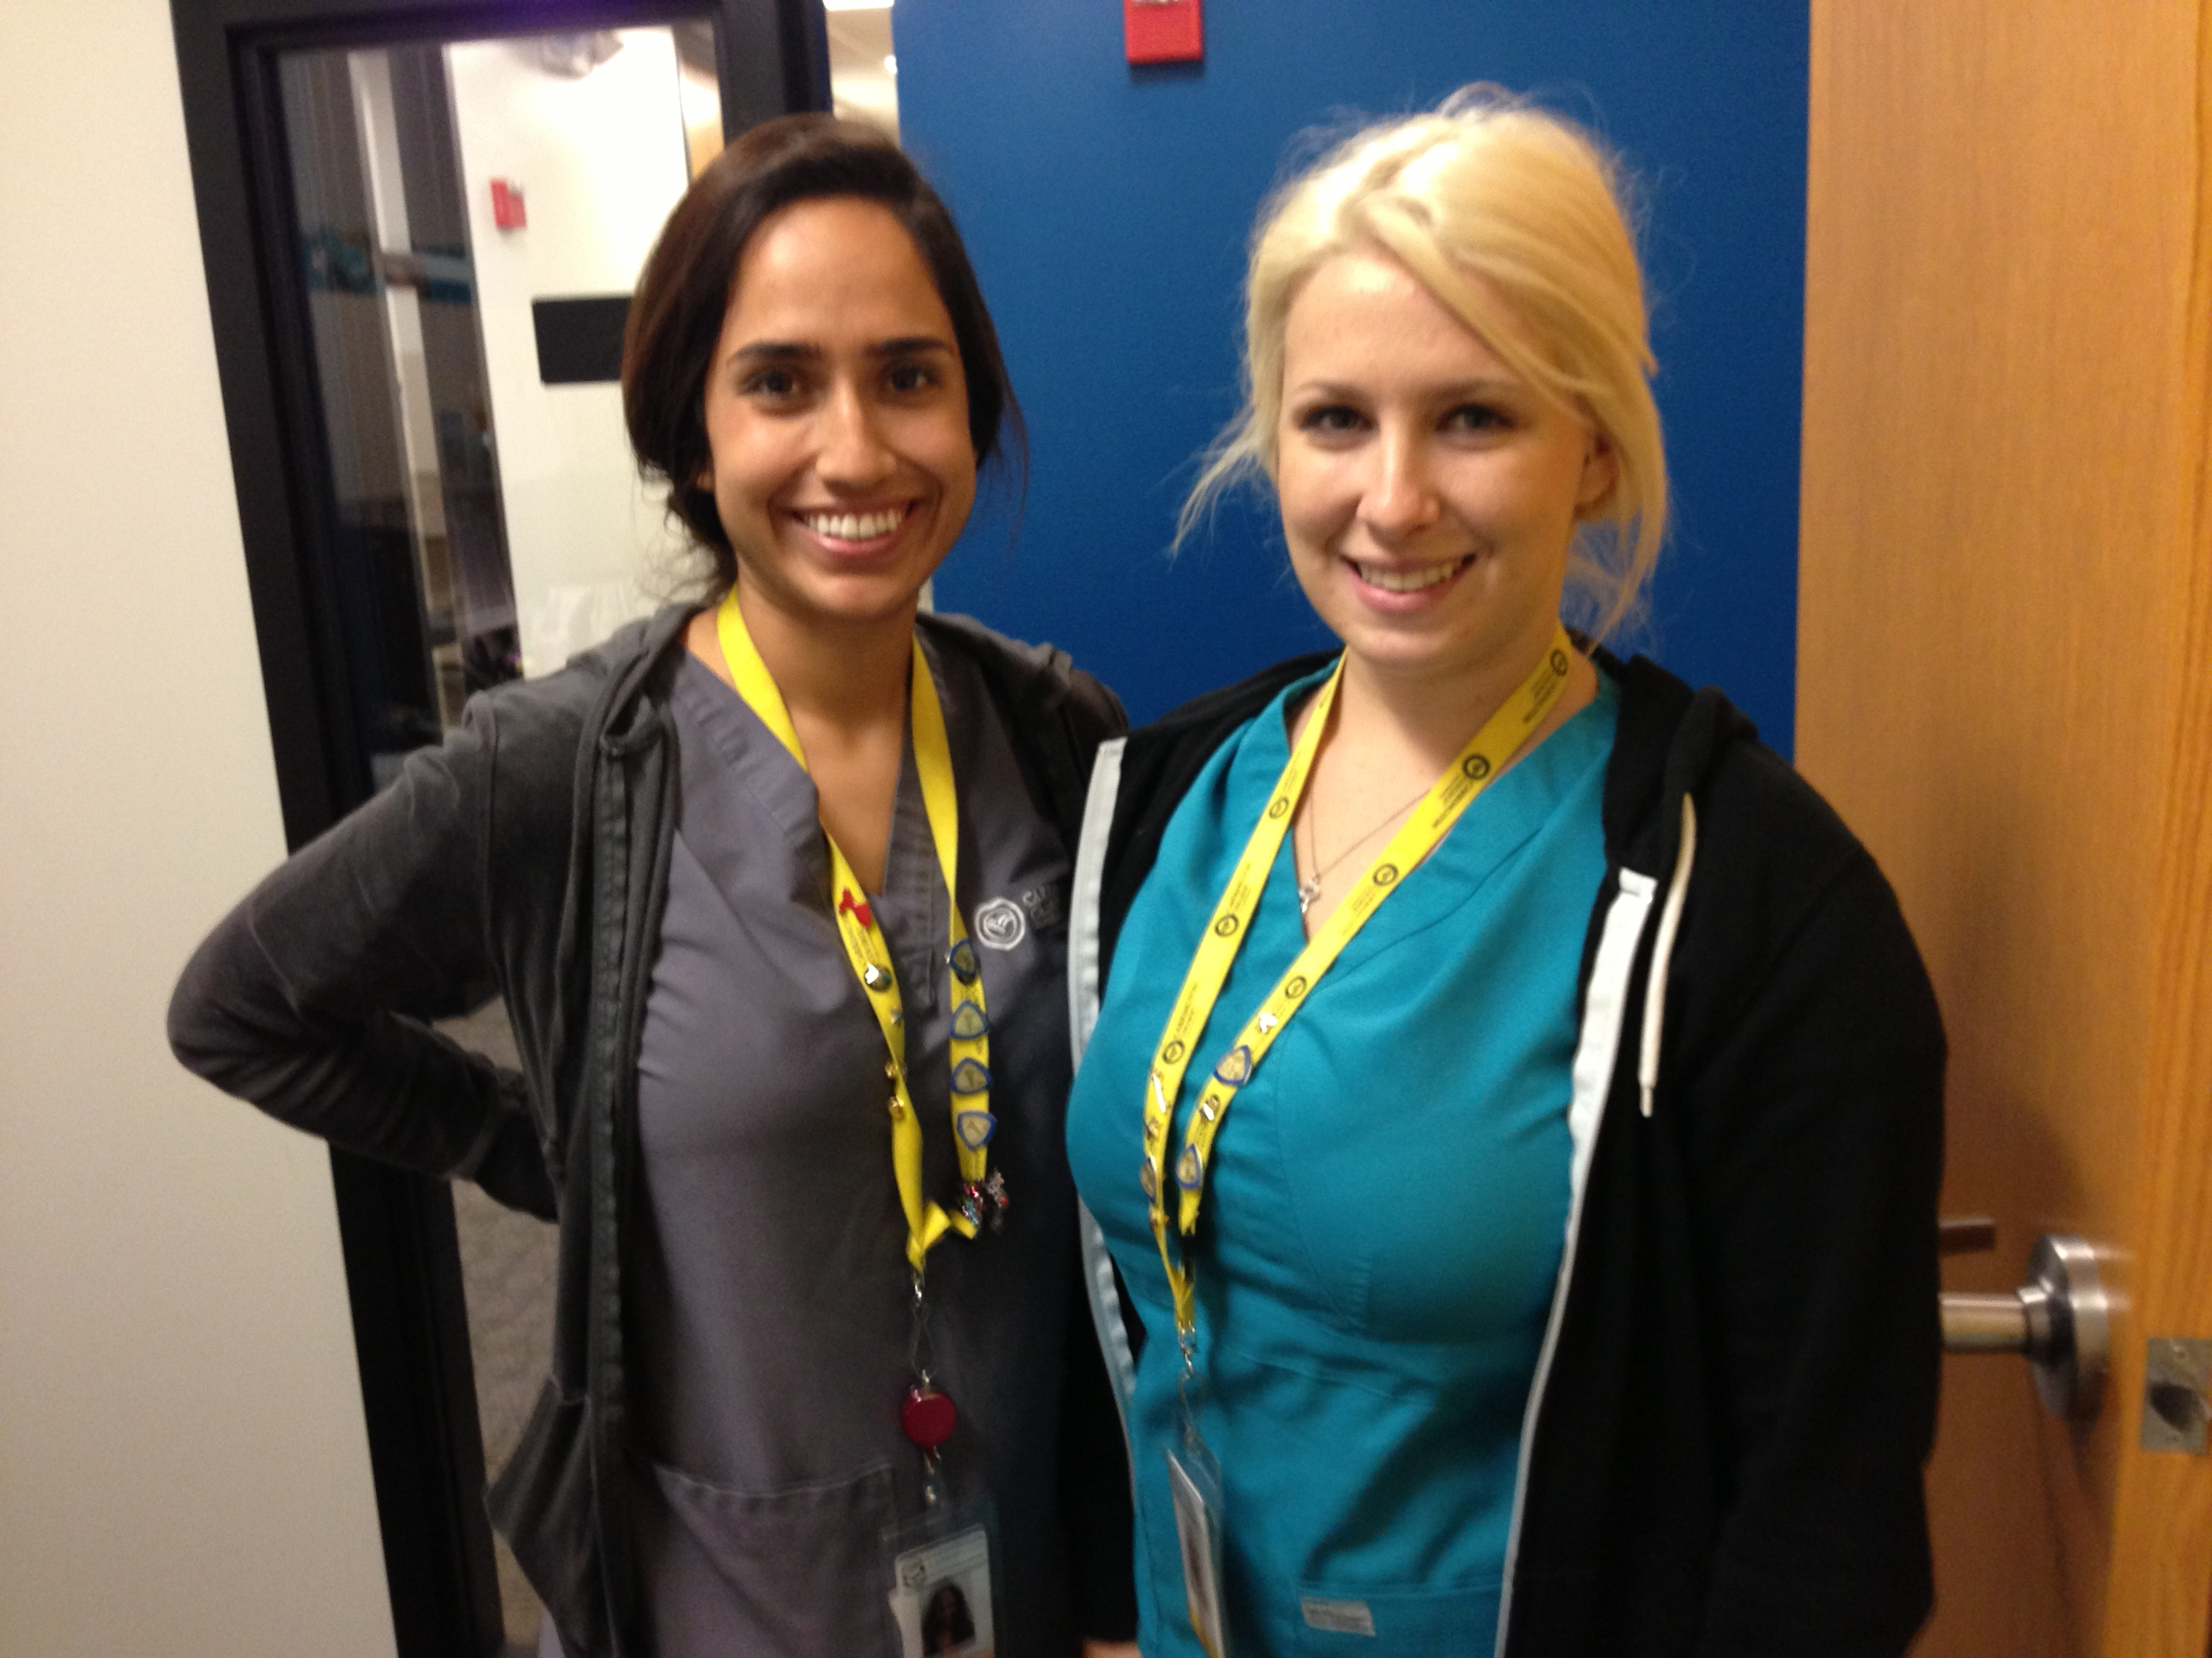
2.5 Two dental students I interviewed after the Cycle One presentation

When I asked them to give me their opinions about career preparation at CCCP, they were very careful to tell me that they think Sandee is doing a great job already. I intuited from their reaction that they did not want to express any dissatisfaction with their experience with Sandee. I agreed with them about what a great job Sandee does, and amended my original question by asking them, “If we could have two Sandees on campus, what else would you like her share with you?” As soon as I asked that question, they were much more relaxed and candid in sharing their opinions.

The students shared that they would like to have more workshops on resume writing and interviewing skills. They explained that they had never been asked to write one before for any of their classes, and therefore had never written one. When I asked if these workshops should be required for all students if I were to present them, they resoundingly indicated that the workshops should be voluntary. They felt that the students who attended these workshops would take more away from the workshops if only those who were truly interested attended.

I brought up the idea of “Interview Fridays,” a regularly scheduled block of time scheduled on Fridays to conduct mock interviews with students who were interested. They were very receptive to this idea, and said that they would definitely take advantage of this opportunity if it were available to them.

Acting Dean Interview, March 25

A note to the reader: At this time, our Acting Dean is also acting as Executive Director on campus. Budget constraints have not allowed the funding for a dedicated, full-time Academic Dean position. Colleen (who hired me) is doing a great job of balancing both roles, but has indicated to me in private conversations that she is looking forward to hiring a full-time Academic Dean and focusing solely on acting as the Executive Director. Her background is in sales and management, and her skills would be better put to use if she could focus on the “ED” role.

After completing my first cycle, (and having a month in my position under my belt) I asked to discuss the educational goals of Carrington College California as an institution. Colleen explained that Carrington College California aims to offer high-quality, rigorous, blended college-preparatory and career-oriented instruction to produce strong results from our students. CCC programs lead to an industry certificate or degree and enable graduates to gain employment in a high-growth industry upon program completion.

CCC stresses that our instructors are talented and successful mid-career professionals whom we have asked to consider leaving their current positions to become CCC instructors. The instructors teach integrated academic, career, and technical content that enables students to better grasp material and that demonstrates connections to real-life career scenarios and choices.

Carrington’s specialized curricula are tailored to the needs of our students, regardless of their educational background, skill level, ethnicity, or cultural orientation. We are committed to keeping our curriculum, teaching methods, and equipment current to meet the needs of our students in being prepared for today’s workplaces.

Our curriculum emphasizes a hands-on, skills-based, and outcomes-based approach. In addition to the vocational skills required for career success, these core student-learning outcomes (SLOs) focus on:

- critical thinking
- information management
- technical literacy
- personal and professional development
- communication skills
- respect and responsibility

Our associate degree programs offer additional online courses focused on general education. Some courses offered online are in communication, mathematics, arts, computer skills, sociology, and psychology.

Carrington College California emphasizes student support. Our deans and managers have open-door policies and encourage students to visit us with any questions or concerns they may have. We take a very active role in ensuring their success in our programs by taking the time to get to know our students. We also watch their grades very closely and offer student support so that the students know that we take an active role in their education.

Career Services Manager Conversation

Sandee is our campus Career Services Manager. She goes out of her way to get to know the students as soon as they begin classes so that she can be familiar with their strengths and weaknesses when placing them in an externship site in their last term at Carrington.

Sandee has an excellent placement percentage in comparison to the other Career Services Managers on other campuses. She believes this has to do with her positive rapport with our students. She also attributes her success to her positive relationships with the externship sites where she places our graduating students.

Her goal is for the hiring managers at the externship sites to keep on the students after they have completed their required hours for class. Some of the externship sites require that the students submit resumes, but others do not. Therefore, she tends to work with students to develop resumes only if they are required.

Sandee is hoping that our campus budget will allow her to hire a full-time assistant so that she can have more time to offer workshops on interviewing skills and resume writing. She also wants to have more time to visit new externship site possibilities as our enrollment numbers continue to increase.

EVALUATION/REFLECTION:
The data analysis of the survey from Cycle One and the conversations with students and staff led me to reconsider whether or not students would benefit from my workshop. I began to wonder if resume writing or cover letter writing would be more appropriate skills for the students to develop through a workshop.
This cycle also led me to the realization that I needed to learn more about career and technical education (CTE). I decided to do a bit of research on CTE and to write a brief literature review so that I could better understand the goals and history of my new career setting.

Career and Technical Education (CTE):
Paving the Way for Employment in the 21st Century

Heidi Bird
Pepperdine University
Master of Arts in Learning Technology

Career and Technical Education (CTE):
Paving the Way for Employment in the 21st Century
In his 2012 State of the Union Address, President Obama laid out a blueprint for an economy “built to last.” In the address, the President stressed that in times of economic challenge, American employers need a workforce that is skilled, adaptable, creative, and equipped for success in the global marketplace. American students need a rigorous, better-tailored education to acquire the skills they need to compete and prosper (United States Department of Education [USDE] Office of Vocational and Adult Education, 2012). Unfortunately, our education and training systems have failed too many of our students and businesses. While the United States ranks ninth in the world in the proportion of young adults (ages 25-34) enrolled in college, we have fallen to sixteenth in the world in proportion of certificates and degrees earned—lagging behind South Korea, Canada, Japan, and others (USDE, 2012).
President Obama set a new goal for the country in his 2012 State of the Union Address: by 2020, America would once again have the highest proportion of college graduates in the world. The President challenged every American to commit to at least one year of higher education or postsecondary training. Transforming career and technical education is essential to meeting this goal and represents a critical investment in our future (USDE, 2012).

Today, postsecondary education and training are prerequisites for jobs of the new economy. Too many of our businesses report that they are having trouble finding workers for skilled jobs in fields such as healthcare, technology, and advanced manufacturing, even in times like today when unemployment is declining but still high. Of the thirty fastest-growing occupations, about two-thirds require postsecondary education or training. Employers turn to Career and Technical Education programs as an important source of talent that they need to fill skilled positions within their companies (USDE, 2012).
In 2011, one in four young high school graduates was unemployed and over half were underemployed. In the past decade, recent high school graduates’ wages have fallen by 12 percent to just $19,400 annually in 2011, below the poverty threshold for a family of four (Carnevale, Jayasundera, Hanson, 2012). These statistics represent a structural change in the United States economy. In 1970, workers with a high school diploma or less represented 74 percent of the middle class. In 1973, nearly three out of four jobs required only a high school education or less. By 2020, two out of three jobs will require some postsecondary education or training (Carnevale et. al, 2012).
As employment opportunities that require only high school diplomas are disappearing, postsecondary education and on-the-job training have become avenues to finding middle class jobs. Although most emphasis for graduating high school students is placed on earning baccalaureate degrees, there has been an increasing interest in training and certification for “middle jobs.” These middle jobs require education and training beyond high school but less than a Bachelor’s degree, and they offer secure middle-class earnings.
The education and training programs that prepare Americans for these jobs are commonly referred to as career and technical education, or CTE (as defined by the Carl D. Perkins Career and Technical Education Improvement Act of 2006). At the postsecondary level, CTE often results in an industry-based certification, a postsecondary certificate, or an Associate’s degree in a particular career or educational pathway. Postsecondary CTE can lead to relatively well-paid jobs that also offer further formal or informal lifelong learning and career advancement in the workplace (Carnevale et. al, 2012).
Although many associate vocational education with non-college bound, at-risk, or special needs students, new career/technical/vocational programs attract a wide range of students, preparing them with skills that increase worker productivity, skill transfer, job access, and job stability (Brown, 2003). CTE offers students opportunities for career awareness and preparation by providing them with the academic and technical knowledge and work-related skills necessary to be successful in post-secondary education, training, and employment. They offer opportunities for students to interact with community members, potential employers, and students and teachers who share similar career/vocational ambitions (Ball, Barton & Dyer, 2001).

In addition, Americans who pursue alternatives to the baccalaureate pathway are not necessarily forgoing a four-year college degree. For example, 28 percent of Americans who earned a Bachelor’s degree in 2009 started at a two-year community college. Americans who earn awards at community colleges are not precluded from earning a Bachelor’s degree later on. One out of every four Americans who earns a postsecondary certificate will continue on to earn a college degree. In addition, 17 percent of Bachelor’s degree holders earned an Associate’s degree beforehand (Carnevale et. al, 2012). Today’s CTE offers broader career pathways than did previous vocational programs. After a decade of academic-vocational integration and tech preparation, it is recognized that school-to-career programs emphasize a dual career path that leaves the option of college open while providing students with marketable skills (Kerka, 2000).

Career and technical education is also a strong option for working students. According to the National Center of Education Statistics, four out of five students work while enrolled in postsecondary institutions and two of those four are working full-time. On average, students are working 30 hours per week. More than 40 percent are older than 24; almost half are financially independent, and a quarter of all postsecondary students have children of their own. Because CTE is career-focused, it has a unique advantage for working learners by providing students with relevant knowledge and skills in order to secure positions that pay more than routine low-level jobs. In addition, students develop career-relevant skills and gain work experience that pays dividends as they advance their careers and save for further education and training.

Conclusion

America’s ability to build a competitive workforce hinges on whether—and to what extent—educators and leaders can continue to develop innovative solutions for preparing all students for college and careers. The changing nature of skills required for existing jobs and the ongoing emergence and technological advances of new jobs demand more responsive program models and hands-on instructional approaches. Strengthening all aspects of our education system and supporting high-quality job-training opportunities are necessary to further our economic prosperity as a nation and to keep the American promise alive for all of our students (USDE, 2012).

CYCLE THREE REPORT

RESEARCH QUESTION:

How can I apply my Cycle Two findings to develop a new workshop focused on more realistic goals for the students?

PREDICTED OUTCOME:

Presenting a workshop on effective cover letter writing will prove to be more helpful for dental assisting students than introducing e-portfolio web-based tools. Survey result data will support my prediction.

ACTION TAKEN:
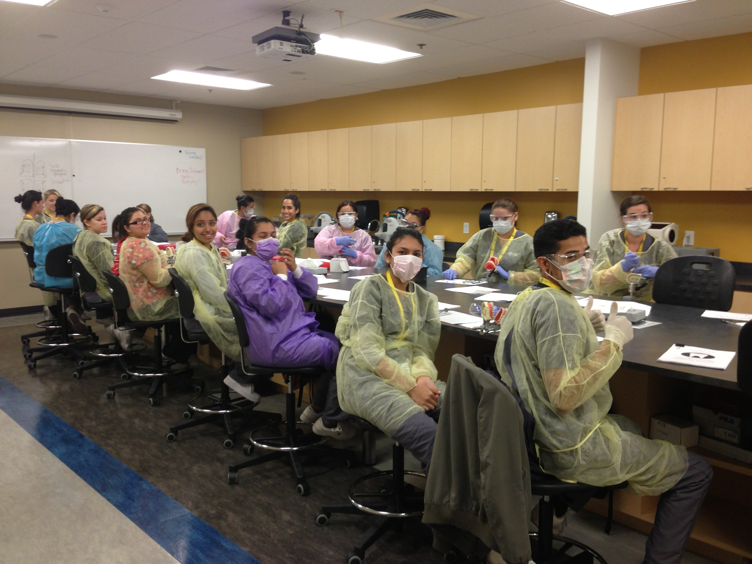
3.1 Dental students in the dental classroom

I presented a Prezi presentation to fifteen dental assisting students in their dental classroom after they had completed a final exam at the end of their term on April 25, 2013. My first step was to introduce myself again to the students, and to explain that the workshop was another requirement for my Masters Degree project. I thanked them for their help with my first cycle, and thanked them in advance for their participation in this final cycle. I asked the students to ask any questions they had as I presented, and also stressed that I would be asking for honest feedback at the end so that I could learn from their input.

Before beginning, I handed out paper copies of the information being presented: the sample cover letter I was using as an example in the Prezi, and the steps of writing an effective cover letter.

Technology utilized in the workshop:
- computer and projector available in the classroom to present the information
- Prezi (www.prezi.com) (see Appendix for screenshots of the Prezi and examples of the cover letter and the steps)

EVIDENCE USED TO EVALUATE THE ACTION:

After completing the workshop, I took an informal student survey. For the first few questions, I asked for verbal answers:

Three key ideas shared today were...
- “Cover letters can present a lot of information.”
- “...what information is important to include in our cover letters.”
- “…how to save a file as a .pdf.”

Two things I learned that I thought were interesting today were...
- “…that I need to follow up after sending in my cover letter and résumé.”
- “…how to address my cover letter.”

One thing I still want to know more about is...
- “…the difference between a résumé and cover letter.”

How useful did you find this workshop?
Fourteen out of fifteen students found the workshop to be “extremely useful.” One in fifteen students found the workshop to be “very useful.”

3.2 Survey Question #1: “How useful did you find this workshop?”

How likely are you to use the skills you learned today in the future?
Fifteen out of fifteen students indicated that they were “very likely” to use the skills learned in the future.

3.3 Survey Question #2: “How likely are you to use the skills you learned today in the future?”

The workshop length was…
Fifteen out of fifteen students indicated that the workshop length was “about right.”

3.4 Survey Question #3: “The workshop length was… ”

How easy was it to understand the content of this workshop?
Fifteen out of fifteen students indicated that is was “extremely easy” to understand the content of the workshop.

3.5 Survey Question #4: “How easy was it to understand the content of this workshop?”

I would like to learn more about…
Three in fifteen students indicated that they would like to learn more about writing a résumé.
Fifteen in fifteen students indicated that they would like to learn more about interviewing skills.
Fifteen out of fifteen students indicated that they would like to learn more about job searching skills.

3.6 Survey Question #5: “I would like to learn more about… ”

How confident are you in your ability to find a new job if you needed to?
I asked them to imagine that there were jobs to be found in the city in which they were searching. Two of fifteen students indicated that they were “very confident” in their ability to find a job. Ten in fifteen students indicated that they were “somewhat confident” in their ability to find a job. Two students indicated that they are “not at all confident” in their ability to find a job. One of fifteen students chose not to answer this question.

3.7 Survey Question #6: “How confident are you in your ability to find a new job if you needed to?”

EVALUATION/REFLECTION:

The clarity and new focus I gained from the survey data collected in Cycle One, the discussion with faculty and students, and the investigation of CTE was integral in the development of my second presentation.

I was extremely pleased with the feedback I received from this workshop. Several students approached me as I was gathering my materials to leave to let me know that they thought that this workshop was very beneficial to them and that they were going to begin to write their own cover letters.

FINAL REFLECTION

Completing my action research project and report has given me new insight into career planning and action research. Foremost in my thoughts is the idea that action research is like a road trip.

As with any successful road trip, action research encourages us to…

Know where you’re headed and map a route to get there.
You may not know exactly where your action research may stop along the way, but you need to have a general destination in mind. Your plan should be specific enough for you to be able to see if you are hitting milestones, but flexible enough that you make room for detours and side trips. Knowing where you want to go allows you to ask good questions and line up the kind of personal support you need to get there.
Dare to take the road less traveled.
Action research encourages you to look up and be aware. Looking around for opportunities and taking advantage of them can take you places you never thought you could go. In action research there is more than one path to success. Flexibility is strength. If your ideas get “stalled out” for a while, you can simply refocus your ideas and get back on the highway.

Traveling with others may make your trip more memorable and enjoyable.

Some people you travel with may have some directions to help you find your way. Others may just make the journey more fun. Learning circles are extremely helpful in providing a forum where you can discuss your ideas and ask questions.

Conclusion

This year has been the most transformative of my educational career. The MALT program has opened my eyes to new ways of thinking and has solidified my educational philosophy. And for the first time in my career, I feel that I have reached my destination. I have arrived at a career I am passionate about.

Instead of focusing on my day-to-day responsibilities, I am now stopping to reflect on how I can best help serve the students at Carrington in the years to come. I am developing strong relationships with the other faculty and staff members so that I am confident that I have a support system on campus. Finally, I am looking to data to support the effectiveness of my ideas. Data is proving to be a key focus of my position. I am tracking student online grades twice a week and entering it into a spreadsheet that I use to keep the instructors and program directors informed of student progress. All of the Carrington campuses also recently completed a student survey which is proving useful for evaluating our program effectiveness. The data from that student survey also affirmed that the students are pleased with the addition of the Student Success Center to the campus. The students indicated that they are very pleased with the new spaced and with the services I am providing.

Along with establishing a support system for the students on campus, I have set myself apart as an educational technology integrator. I have introduced the faculty to prezi.com as a tool to use instead of PowerPoint. I have also introduced popplet.com as a brainstorming tool they can use to review material for tests. Recently, I went to each Vet Tech class and gave a short presentation on studyblue.com, a website that allows you to create (or share already created) digital notecards to replace paper notecards (as well as utilize the information on the cards as a study guide or create a quiz). It is already becoming a popular web tool for the students.

I am so pleased to have finally settled into a work environment where my educational philosophy and my strengths are appreciated. Every day, I am reminded in small ways that my efforts to improve student success are appreciated by students and staff. Action research has become an invaluable tool in developing my role on campus. As I continue down my career path on campus, I plan to utilize the tools I have learned from action research. In particular, I plan to continue to foster positive working relationships with my coworkers to reflect on my actions and plans for potential long-term student success benefits.

References

Ball, A. L., Barton, B. L., & Dyer, J. E. (2001). The Influence of Learning Communities and 4-H/FFA Participation on College of Agriculture Students’ Academic Performance and Retention. Retrieved from http://www.eric.ed.gov/ website: http://www.eric.ed.gov/ERICWebPortal/search/detailmini.jsp?_nfpb=true&_&ERICExtSearch_SearchValue_0=EJ638594&ERICExtSearch_SearchType_0=no&accno=EJ638594
Barrett, H. C. (2007). Researching electronic portfolios and learner engagement: The REFLECT initiative. Journal of Adolescent & Adult Literacy, 50(6), 436-449.
Barrett, H., & Carney, J. (2005). Conflicting paradigms and competing purposes in electronic portfolio development. Retrieved from https://www1.taskstream.com/
Brown, B. L. (2003). Benefits of Career and Technical Education Trends and Issues Alert 49. Retrieved from www.calpro-online.org website: http://www.calpro-online.org/eric/docs/tia00117.pdf
Cambridge, B. & Cambridge, D. (2003). The future of electronic portfolio technology: supporting what we know about learning e-Portfolio. Poitiers, France. http://www.eife-l.org/portfolio
Cambridge, D. (2008). Universities as responsive learning organizations through competency-based assessment with electronic portfolios. JGE: The Journal of General Education, 57(1), 51-64. Retrieved from http://web.ebscohost.com.lib.pepperdine.edu/ehost
Carnivale, A. P., Jayasundara, T., & Hanson, A. R. (2012, September 18). Career and Technical Education: Five Ways That Pay. Retrieved from http://www.insidehighered.com/sites/default/server_files/files/CTE_FiveWays_FullReport_Embargoed.pdf
Investing in America’s Future: A Blueprint for Transforming Career and Technical Education. (2012). United States Department of Education Office of Vocational and Adult Education, 1-fifteen.
Jenson, J. (2011). Promoting self-regulation and critical reflection through writing students’ use of Electronic Portfolio. International Journal of ePortfolio, 1(1), 49-60.
Kerka, S. (2000). Career and Technical Education: A New Look. In Brief: Fast Facts for Policy and Practice No. 8. Retrieved from http://www.nccte.org/ publications website: http://www.nccte.org/ publications/infosynthesis/in-brief/in-brief08/index.asp
Knight, W. E., Hakel, M. D., & Gromko, M. (2006). The relationship between electronic portfolio participation and student success. In Annual Forum of the Association for Institutional Research.(ERIC Document Reproduction Service No. ED 493 824).
Mason, R., Pegler, C., & Weller, M. (2004). E‐portfolios: an assessment tool for online courses. British Journal of Educational Technology, 35(6), 717-727.
McAlpine, M. (2005). E-portfolios and Digital Identity: some issues for discussion. E-Learning and Digital Media, 2(4), 378-387.
Rhodes, T. L. (2010). Making learning visible and meaningful through electronic portfolios. Change: The Magazine of Higher Learning, 43(1), 6-13.
Rodgers, C. (2002). Defining reflection: Another look at John Dewey and reflective thinking. The Teachers College Record, 104(4), 842-866.
Shepherd, C. E., & Hannafin, M. J. (2008). Examining preservice teacher inquiry through video-based, formative assessment e-portfolios. Journal of Computing in Teacher Education, 25(1), 31-37.
Tubaishat, A., Lansari, A., & Akram, A.-R. (2009). E-portfolio assessment system for an outcome-based information technology curriculum. Journal of Information Technology Education, 8, IIP-43-IIP-54. Retrieved from http://web.ebscohost.com.lib.pepperdine.edu/ehost
Villano, M. (2006, August 29). Electronic student assessment: the power of the portfolio. Campus Technology. Retrieved from http://campustechnology.com/Articles/2006/08/Electronic-Student-Assessment-The-Power-of-the-Portfolio.aspx?Page=2
Whitworth, J., Deering, T., Hardy, S., & Jones, S. (2011). Perceptions Regarding the Efficacy and Use of Professional Portfolios in the Employment of Teachers. International Journal, 1(1), 95-106.
Young, J. (2002). Creating online portfolios can help students see ‘big picture,’ colleges say. The Chronicle of Higher Education, 21.

